CS 471/571 Assignment #4

Full Name: Milson Munakami

Turn in your work as a single file via Blackboard. Make sure your full name is included in the file name. Handwritten answers will not be accepted. Total points: 80.

- Perform the requirements workflow for an automated library circulation system. Every book has a bar code, and every borrower has a card bearing a bar code. When checking out a book, the librarian scans the borrower’s card and the bar code on the book. When a borrower wishes to return a book, the librarian scans it. Librarians can add books to the library collection or remove them. Borrowers can go to a terminal and determine all the books in the library by a particular author, all the books with a specific title, or all the books in a particular subject area. If a borrower wants a book currently checked out, the librarian can place a hold on the book so that, when it is returned, it will be held for the borrower who requested it. Submit the following documents:
  - A use case diagram that includes the main use cases. (20 points)
Answer:
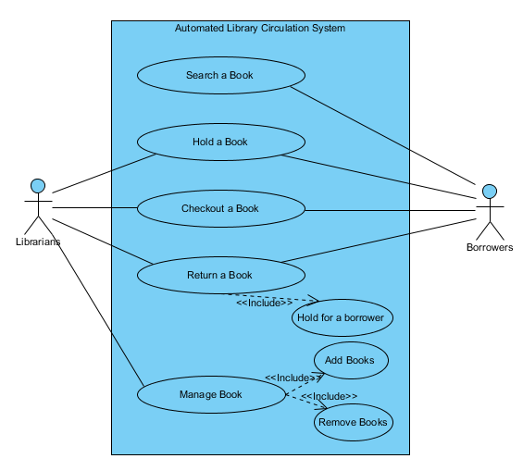
  - Use case descriptions of the main use cases in (a). The description of each use case should include a brief description and a step-by-step description. (20 points)
Answer:
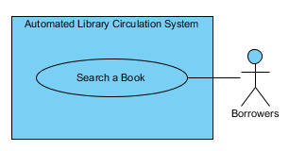
Brief Description
The Search a Book user case enables Borrowers to determine all the books in the library by a particular author, all the books with a specific title, or all the books in a particular subject area.
Step-by-Step Description
- Borrower go to a terminal
- Borrower can search all the books in library collection based on a particular author, a specific title or a particular subject area.

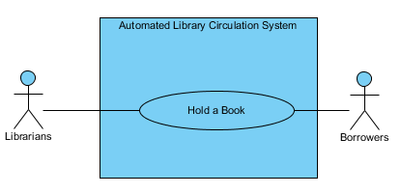
Brief Description
The Hold a Book user case enables Borrowers to reserve a book, the Librarian can place a hold on the book to reserve it for the Borrower.
Step-by-Step Description
- If a Borrower wants a book currently checked out, the Librarian can place a hold on the book so that when it is returned, it will be held for the borrower who requested it.

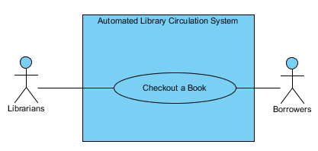
Brief Description
The Checkout a Book user case enables Borrowers to check out a book, the librarian scans the borrower’s card and the bar code on the book
Step-by-Step Description
- If a Borrower wants a book to check out, the Librarian can scans the borrower’s card and the bar code on the book.

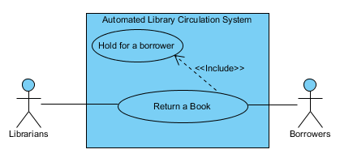
Brief Description
The Return a Book user case enables Borrowers to return the book to a Librarian who scans its bar code.
Step-by-Step Description
- Borrower returns a book
- Librarian will scan its Bar code
- If the book has been placed a hold Status for a borrower then it will be held for the borrower who had requested it.

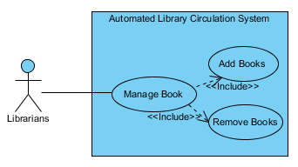

Brief Description
The Manage Book user case enables Librarians to add books to the library collection or remove them.
Step-by-Step Description
1. Update, add and remove a book from the library collection.

- Suppose the MSG foundation wants to include “Manage an MSG Mortgage Application” use case. An MSG staff grants the mortgage application only if (1) the price of the home must be below the published median price in that area for the past 12 months, (2) MSG has sufficient funds on hand to purchase the home, and (3) the total weekly payment (including P & I, insurance premiums, and real-estate taxes) is less than 35% of the borrower’s total weekly income. Conduct the analysis workflow for the above use case. You can introduce new classes if necessary.

  - Describe a typical use case scenario where an MSG staff grants a mortgage. (10 points)
Answer:

Brief Description
When a borrower applies for a mortgage, the Manage an MSG Mortgage Application use case enables an MSG staff member to determine whether the mortgage can be granted
Step-by-Step Description
1. The MSG staff member checks:
- Whether the price of the home that the borrower wishes to purchase is below the published median price in that area for the past 12 months.
- Whether the foundation has sufficient funds on hand this week to purchase the home.
- Whether the total weekly payment (including P & I, insurance premiums, and real-estate taxes) is less than 35% of the borrower’s total weekly income.
2. If all these conditions are satisfied, the mortgage is granted.

  - Draw a sequence diagram for the scenario in (a). (10 points)
Answer:
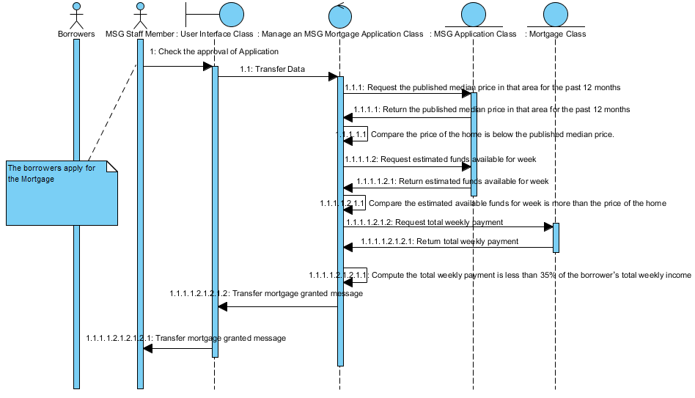

  - Describe a typical use case scenarios where an MSG cannot grant a mortgage because the applicant is not qualified. (10 points)
Answer:

Brief Description
When a borrower applies for a mortgage, the Manage an MSG Mortgage Application use case enables an MSG staff member to determine whether the mortgage cannot be granted (denied!).
Step-by-Step Description
1. The MSG staff member checks:
- Whether the price of the home that the borrower wishes to purchase is below the published median price in that area for the past 12 months.
- Whether the foundation has sufficient funds on hand this week to purchase the home.
- Whether the total weekly payment (including P & I, insurance premiums, and real-estate taxes) is less than 35% of the borrower’s total weekly income.
2. If any of the above three conditions are not met, the mortgage is denied. For this scenario, I consider the 3rd condition is false i.e. the total weekly payment (including P & I, insurance premiums, and real-estate taxes) is greater than 35% of the borrower’s total weekly income.
  - Draw a sequence diagram for the scenario in (c). (10 points)
Answer:

